Brainstorming & Idea Prioritization Template

Date | 30 October 2025
Team ID | NM2025TMID01741
Project Name | Calculating Family Expense Using ServiceNow
Maximum Marks | 4 Marks

Brainstorming & Idea Prioritization Template

Brainstorming provides a creative environment that encourages team members to collaborate and generate innovative ideas. In this project, our goal was to develop a system for calculating and tracking family expenses using ServiceNow. The brainstorming session allowed us to identify key problems, generate solutions, and prioritize feasible ideas for implementation.

Step 1: Team Gathering, Collaboration and Problem Selection

Our team collaborated to identify a real-world problem that could be automated using ServiceNow. After several discussions, we selected 'Calculating Family Expenses' as our project focus. The challenge was to build a system that could record, categorize, and analyze household expenses efficiently, providing insights through reports and dashboards.

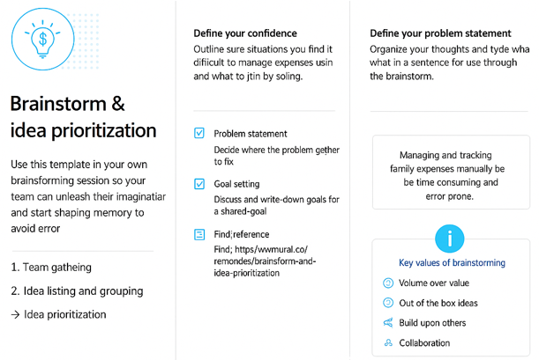

Step 2: Brainstorming, Idea Listing and Grouping

We listed all potential ideas for developing the system using ServiceNow. Each idea was discussed, grouped, and evaluated based on feasibility and impact.
Ideas generated included:
- Creating a user-friendly expense submission form in ServiceNow.
- Categorizing expenses (e.g., groceries, utilities, education, travel).
- Automating total monthly expense calculations.
- Generating visual expense reports and analytics.
- Sending automated budget alerts when limits are exceeded
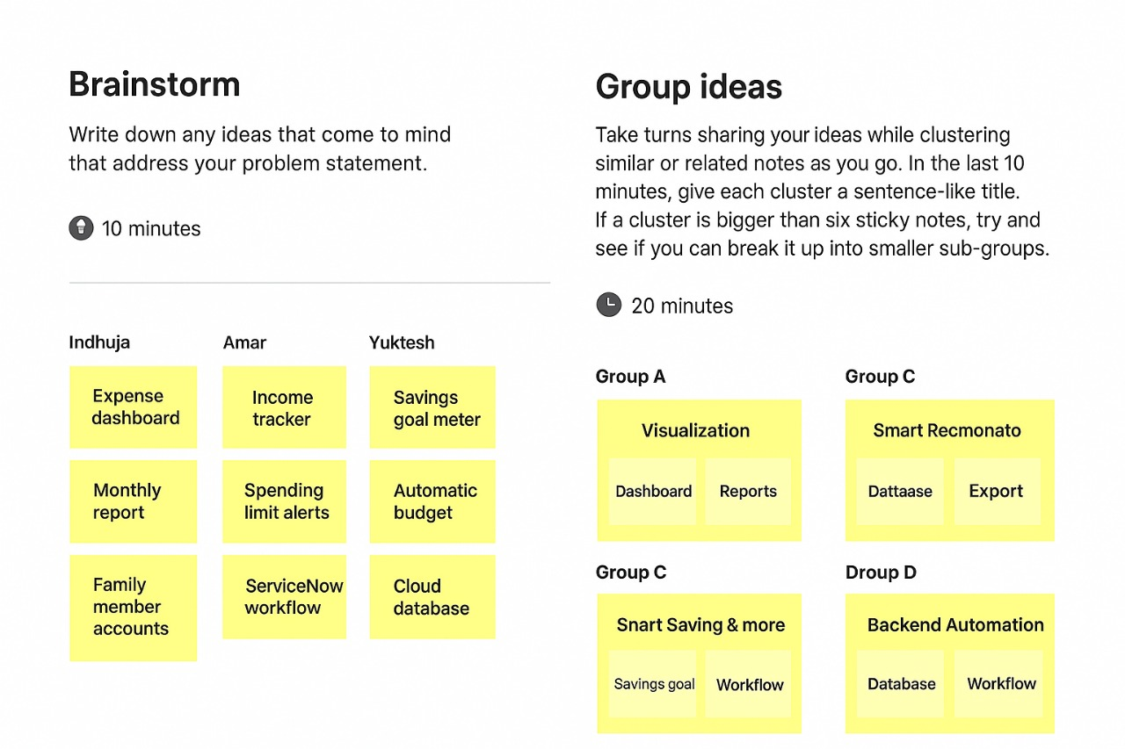.
Step 3: Idea Prioritization
After listing all ideas, we used prioritization techniques like impact vs. feasibility analysis. High-impact and easy-to-implement ideas were chosen for the project’s first phase.
Prioritized ideas:
1. Expense recording and categorization form.
2. Automated monthly calculation module.
3. Dashboard for visualization.
4. Alert system for budget control.
